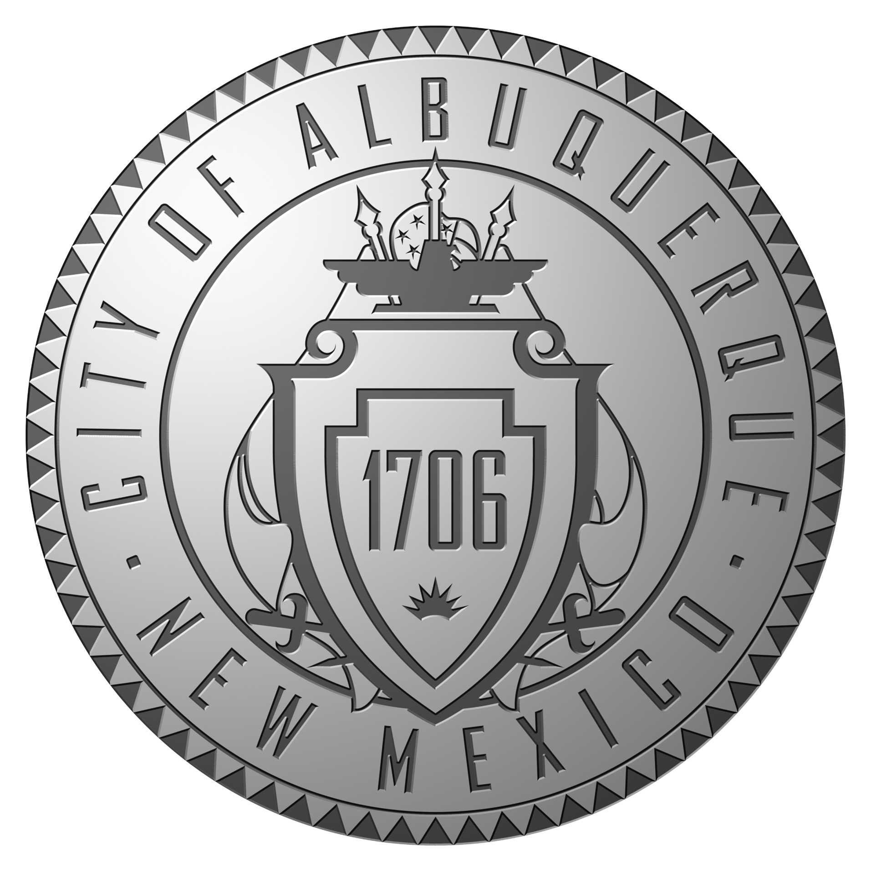
City of Albuquerque

Human Resources Department

Richard J. Berry, Mayor

Agenda- Intention to Consider the Adoption of a Rule or Regulation Pertaining to Personnel – Substance Abuse Policy
Date Posted: May 3, 2011

Vincent A. Yermal, Hearing Officer

Wednesday, May 18, 2011

9:00 a.m.

Council Committee Room, City Hall, 9th Floor

Item1. Call to Order

Item 2. Proposed revisions to the Personnel Rules and Regulations of the City of Albuquerque. This hearing will address the revisions and reformatting to the City’s Substance Abuse Policy. (Copy of proposed revisions to the Substance Abuse Policy may viewed online at www.cabq.gov/clerk)

Item 3. Public Comment

Item 4. Adjourn

POSTED AT CITY/COUNTY GOVERNMENT CENTER, ONE CIVIC PLAZA
ALSO AVAILABLE AT WWW.CABQ.GOV/CLERK

